

**MEMORANDUM OF UNDERSTANDING**

This is a document validating an agreement between **MR. OGABOR JOHN AND MR. OLU FATAI** for the collaborative of 20% interest over a sum of **SEVENTY THOUSAND NAIRA ONLY (N70,000) paid on the 14th of May, 2020.**

There is a binding agreement to pay the initial capital invested, alongside the interest, **EIGHTY FOUR THOUSAND NAIRA ONLY (N84,000) on the 14th of June, 2020** by **MR. OGABOR JOHN TO MR. OLU FATAI.**

Attached with this document is an evidence of payment by **MR. OLU FATAI.**

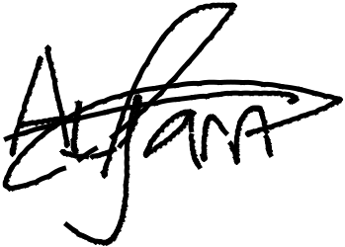

_________________________

_~~__~~_____~~___~~_~~_~~___________



**MR. OLU FATAI**

**MR. OGABOR JOHN**

***(CEO, JOHN INVESTMENTS)***